**:** **Array and Pointer:**

Name: PAWAN KUMAR MEENA

Roll No:21UFIE2085 Branch : cse

**1.** [**C Program to Find Transpose of a Matrix**](https://www.programiz.com/c-programming/examples/matrix-transpose)**.**

**Program::**

#include <stdio.h>

int main()

{

int mat[5][5];

int r, c;

printf("::Enter the number of rows and column::\n");

scanf("%d%d", &r, &c);

printf("Enter the elements of the metrix::\n");

for (int i = 0; i < r; i++)

{

for (int j = 0; j < c; j++)

{

scanf("%d", &mat[i][j]);

}

}

printf("\n\nElements of the metrix::\n");

for (int i = 0; i < r; i++)

{

for (int j = 0; j < c; j++)

{

printf("%d ", mat[i][j]);

}

printf("\n");

}

printf("\n\n::Transpose of the metrix::\n");

for (int i = 0; i < r; i++)

{

for (int j = 0; j < c; j++)

{

printf("%d ", mat[j][i]);

}

printf("\n");

}

return 0;

}

**Output::**

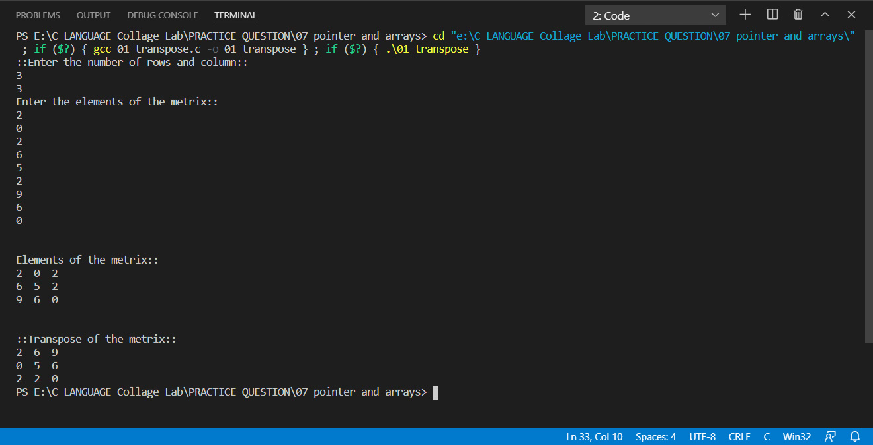

**2.** [**C Program to Multiply two Matrices by Passing Matrix to a Function**](https://www.programiz.com/c-programming/examples/matrix-multiplication-function)**.**

**Program::**

#include <stdio.h>

void mult_mat(int m1[][5], int m2[][5], int, int, int, int);

int main()

{

int mat1[5][5], mat2[5][5];

int r1, c1, r2, c2;

/*For multiplation of two metrix row of the first metrix should be equal to column of

second metrix.And colmun of first metrx should be equal to row of second metrix*/

printf("::Enter the number of rows and column of first metrix::\n");

scanf("%d%d", &r1, &c1);

printf("::Enter the number of rows and column of second metrix::\n");

scanf("%d%d", &r2, &c2);

if (r1 != c2 || c1 != r2)

{

printf("Error!Row of the first matrix not equal to colmun of secont metrix:\n");

printf("::Enter the number of rows and column of first metrix::\n");

scanf("%d%d", &r1, &c1);

printf("::Enter the number of rows and column of second metrix::\n");

scanf("%d%d", &r2, &c2);

}

printf("Enter the elements of the first metrix::\n");

for (int i = 0; i < r1; i++)

{

for (int j = 0; j < c1; j++)

{

scanf("%d", &mat1[i][j]);

}

}

printf("Enter the elements of the second metrix::\n");

for (int i = 0; i < r2; i++)

{

for (int j = 0; j < c2; j++)

{

scanf("%d", &mat2[i][j]);

}

}

mult_mat(mat1, mat2, r1, c1, r2, c2);

return 0;

}

void mult_mat(int m1[][5], int m2[][5], int r1, int c1, int r2, int c2)

{

int result[5][5];

// r1==c2 and c1==r2

printf("\n\nElements of the first metrix::\n");

for (int i = 0; i < r1; i++)

{

for (int j = 0; j < c1; j++)

{

printf("%d ", m1[i][j]);

}

printf("\n");

}

printf("\n\nElements of the second metrix::\n");

for (int i = 0; i < r2; i++)

{

for (int j = 0; j < c2; j++)

{

printf("%d ", m2[i][j]);

}

printf("\n");

}

for (int i = 0; i < r1; i++)

{

for (int j = 0; j < c2; j++)

{

result[i][j] = 0;

for (int k = 0; k < c1; k++)

{

result[i][j] = result[i][j] + m1[i][k] * m2[k][j];

}

}

}

printf("::Product of two metrix::\n");

for (int i = 0; i < r1; i++)

{

for (int j = 0; j <c2; j++)

{

printf("%d\t",result[i][j]);

}

printf("\n");

}

}

**Output::**

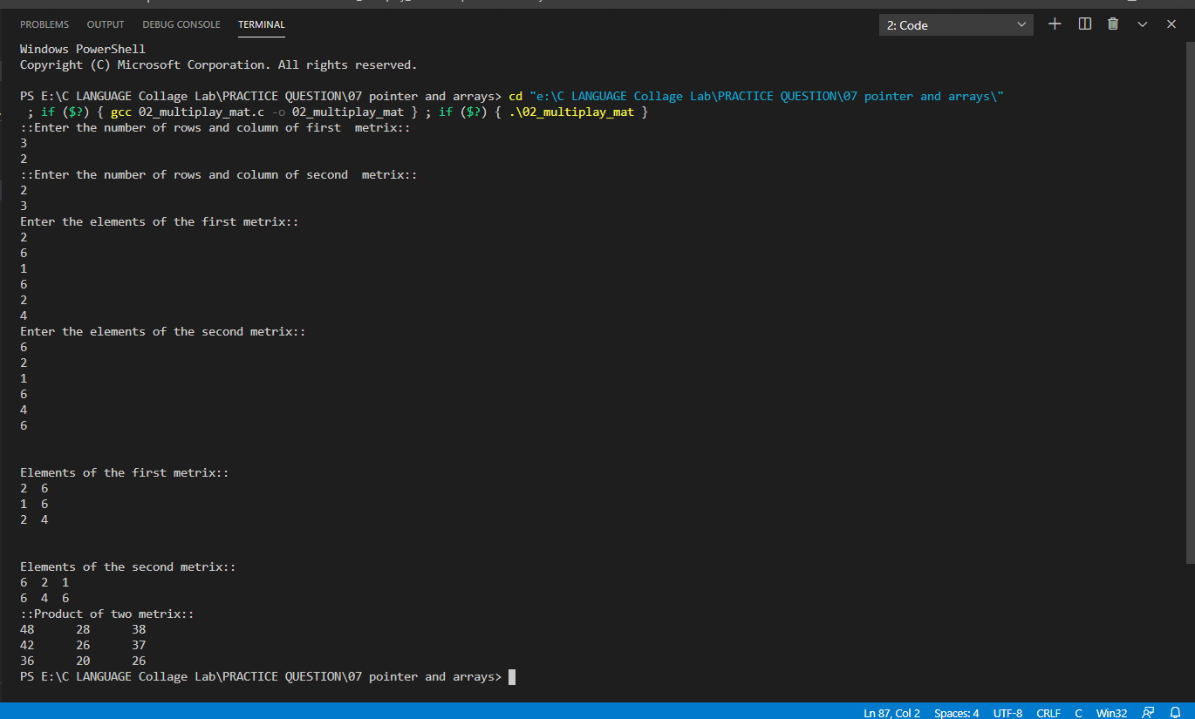

**3.** [**C Program to Access Elements of an Array Using Pointer**](https://www.programiz.com/c-programming/examples/access-array-pointer)**.**

**Program::**

#include <stdio.h>

void acess(int *);

int main()

{

int array[10];

printf("Enter the elements of the array::\n");

for (int i = 0; i < 10; i++)

{

printf("Enter the %d elements of the array::\n", i + 1);

scanf("%d", &array[i]);

}

printf("Access elements of the arrays using Pointer::\n");

acess(array);

return 0;

}

void acess(int *a)

{

for (int i = 0; i < 10; i++)

{

printf("%d Elements of the array = %d\n", i + 1, *a);

a++;

}

}

**Output::**

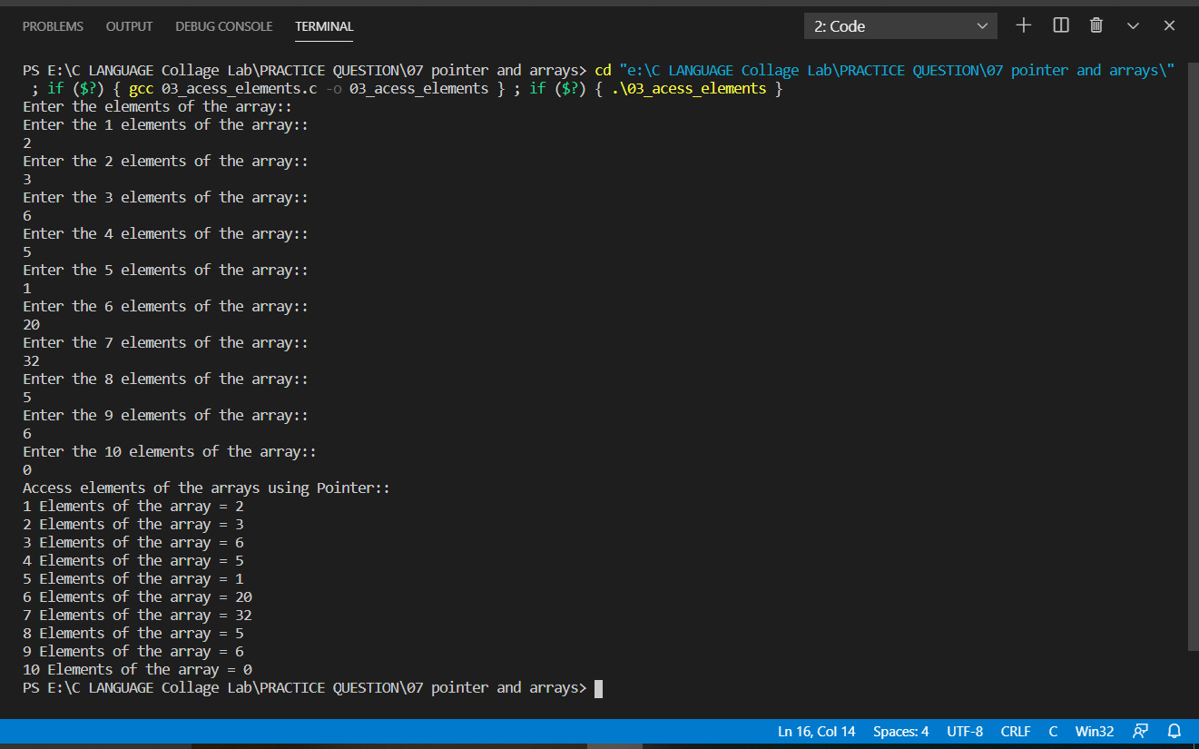

**4.** [**C Program Swap Numbers in Cyclic Order Using Call by Reference**](https://www.programiz.com/c-programming/examples/swapping-cyclic-order)**.**

**Program::**

#include <stdio.h>

int sweap(int *, int *, int *);

int main()

{

int num1, num2, num3;

printf("Enter the three numbr repectivily::\n");

scanf("%d%d%d", &num1, &num2, &num3);

printf("::Values before sweaping::\n");

printf("num1 = %d\nnum2 = %d\nnum3 = %d\n", num1, num2, num3);

sweap(&num1, &num2, &num3);

printf("::Values after sweaping::\n");

printf("num1 = %d\nnum2 = %d\nnum3 = %d\n", num1, num2, num3);

return 0;

}

int sweap(int *n1, int *n2, int *n3)

{

int temp;

temp=*n1;

*n1=*n2;

*n2=*n3;

*n3=temp;

}

**Output::**

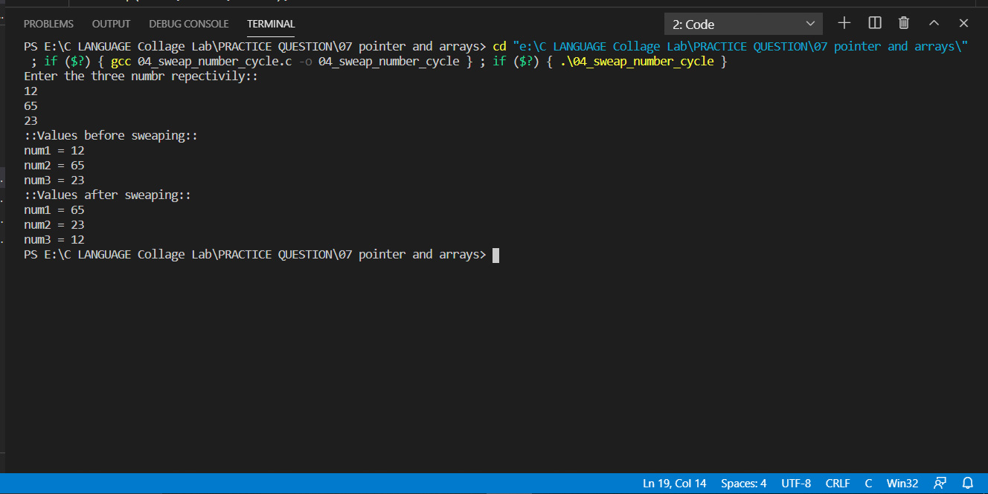

**5.** [**C Program to Find Largest Number Using Dynamic Memory Allocation**](https://www.programiz.com/c-programming/examples/dynamic-memory-allocation-largest)**.**

**Program::**

#include <stdio.h>

#include <stdlib.h>

int main()

{

int *ptr;

int num, larg_num = 0;

printf("Enter the size of array::\n");

scanf("%d", &num);

ptr = (int *)malloc(num * sizeof(int));

if (ptr == NULL)

{

printf("Error!! Memory doesn't allocated::\n");

}

else

{

for (int i = 0; i < num; i++)

{

printf("Enter the value of %d element of array ::\n", i + 1);

scanf("%d", &ptr[i]);

}

for (int i = 0; i < num; i++)

{

if (ptr[i] > larg_num)

{

larg_num = ptr[i];

}

}

printf("Largest number of the array is %d.\n", larg_num);

}

return 0;

}

**Output::**

